


LEARNERS WORKBOOK
MODULE 2 - Creative Business Models and Emerging Trends
Use this workbook to capture the key learning from Module 2

EXERCISE 1: WATCH - Learn how to hustle? (reference Slide 21)
http://www.forbes.com/sites/85broads/2013/12/10/learning-how-to-hustle/#6415c8ca47f3
Record your learning below:
________________________________________________________________________________________________________________________________________________________________________________________________________________________________________________________________________________

EXERCISE 2: VISIT https://www.garyvaynerchuk.com/blog/ (reference Slide 22) Be prepared for colourful language ☺. How can you apply these approaches in your new creative business? Record your learning below:
________________________________________________________________________________________________________________________________________________________________________________________________________________________________________________________________________________
________________________________________________________________________________________________________________________________________________________________________________________________________________________________________________________________________________
Creative Communities Igniting Change is an project to challenge, empower and stimulate community creativity and entrepreneurship. www.creativecommunities.how

EXERCISE 3: WATCH https://youtu.be/z5tugxy70MY and
https://youtu.be/S4bAVgMJo8w (reference Slide 22)

Record your learning below:
________________________________________________________________________________________________________________________________________________________________________________________________________________________________________________________________________________

EXERCISE 4: REVIEW Brent Galloway’s Sample Business Plan paying particular attention to his marketing message http://cl.ly/Q6jd (reference Slide 23)

Record your learning below:
________________________________________________________________________________________________________________________________________________________________________________________________________________________________________________________________________________

EXERCISE 5: READ ”One Person, Multiple Careers” (Marci Alboher) (reference Slide 28) http://heymarci.com/book-slash-careers/fullmedialist/ny-law-journal/
https://www.amazon.com/One-Person-Multiple-Careers-Success/dp/B001Q3M79M

Record your learning below:
________________________________________________________________________________________________________________________________________________________________________________________________________________________________________________________________________________

EXERCISE 6: READ Portfolio Career “ And do what you do ?” (reference Slide 34)
https://www.amazon.com/What-Do-You-creating-portfolio-ebook/dp/B00UFPPBOU/ref=asap_bc?ie=UTF8

Record your learning below:
________________________________________________________________________________________________________________________________________________________________________________________________________________________________________________________________________________

EXERCISE 7: Talk about your career in terms of a slash career (reference Slide 35)
- Mapping exercise – map out your skills
- Where are the gaps?
- What other skills can you offer to others? (this will help you with your business and marketing planning)

________________________________________________________________________________________________________________________________________________________________________________________________________________________________________________________________________________________________________________________________________________________________________________________________________________________________________________________________________________________________________________________________________________________________

Exercise 8: REPLICATE Shakespeare’s mind map. Sketch an image of yourself at the centre of the mindmap and spend 30 mins mapping out your mindmap based on the example (reference Slides 37 and 38)
http://www.tonybuzan.com/about/mind-mapping/

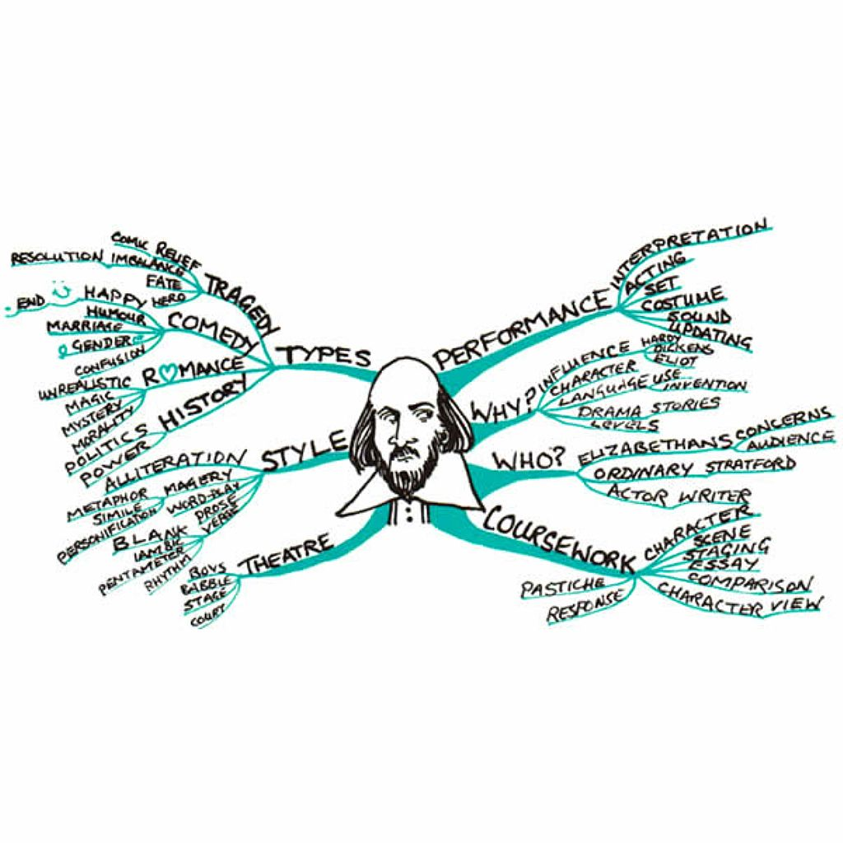
RESOURCES - More about mindmapping
- Online https://www.mindjet.com/
- 8 free mind mapping tools - http://www.makeuseof.com/tag/8-free-mind-map-tools-best-use/

EXERCISE 9 – WATCH Portfolios - Other Resources (reference Slide 53)
- Tutorial: How To make a Behance portfolio https://www.youtube.com/watch?v=Wdp3fL5Qfss
- Watch a day in the life of a graphic designer https://www.youtube.com/watch?v=h7_xYUcKNzw
- Creating a Wix Portfolio: Getting Started watch: www.youtube.com/watch?v=Dwcvj5QI54k
- David Parrish: Empowerment through creative entrepreneurship https://www.youtube.com/watch?v=3osDHrxaQzg

EXERCISE 10 – WATCH The Influencers
- Watch documentary online for free http://documentarystorm.com/influencers/

Record your learning below:
________________________________________________________________________________________________________________________________________________________________________________________________________________________________________________________________________________

"The European Commission support for the production of this publication does not constitute an endorsement of the contents which reflects the views only of the authors, and the Commission cannot be held responsible for any use which may be made of the information contained therein."

